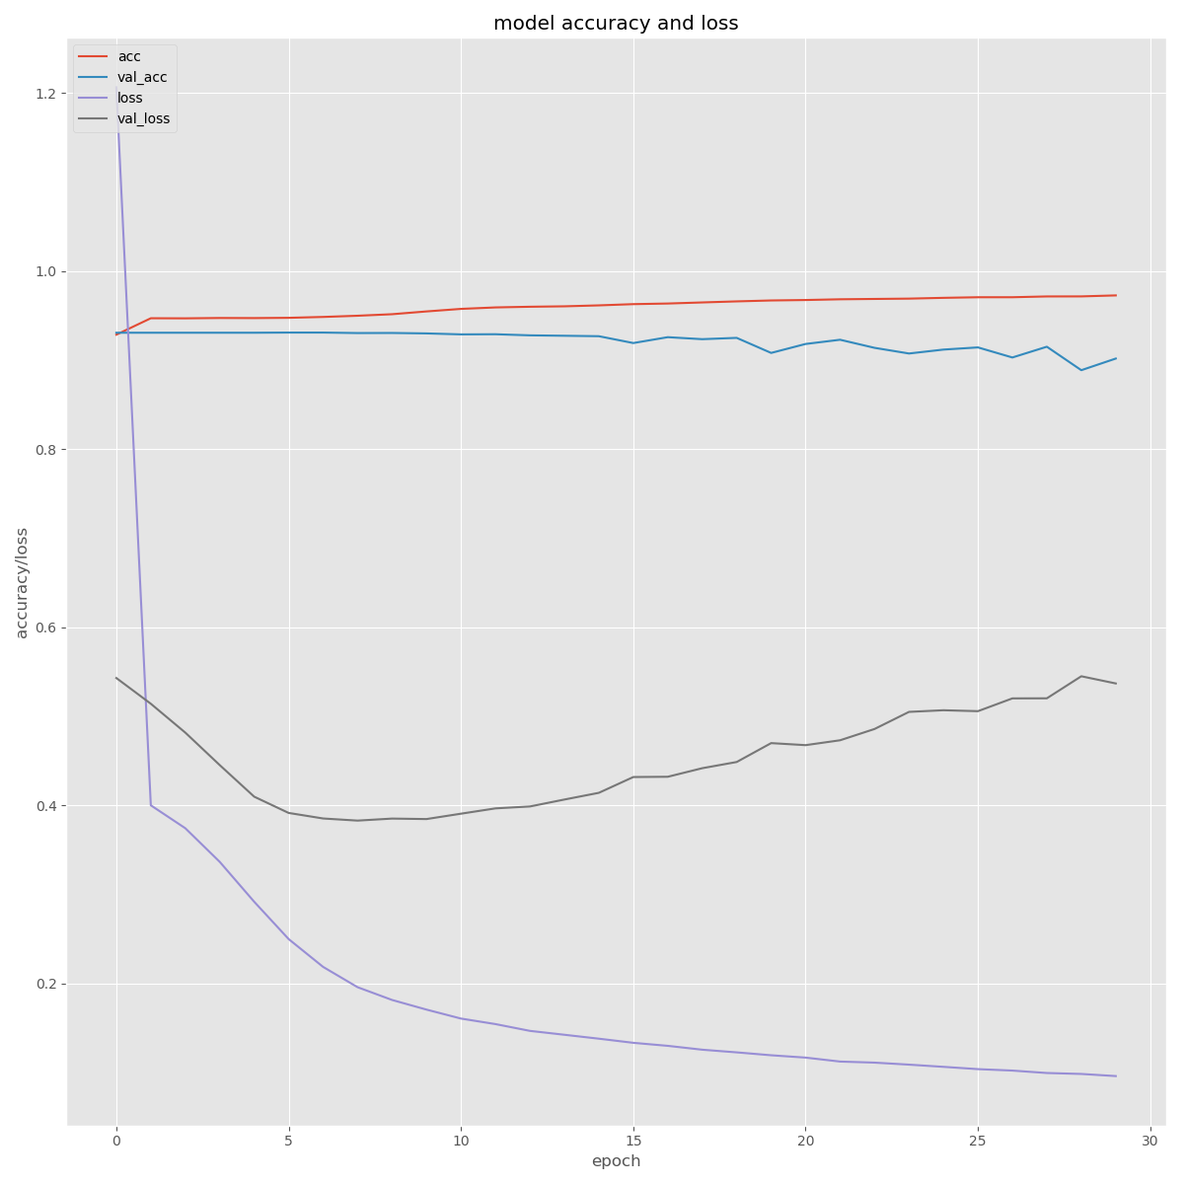
Fig 1: graph for validation loss and accuracy for 30 epochs
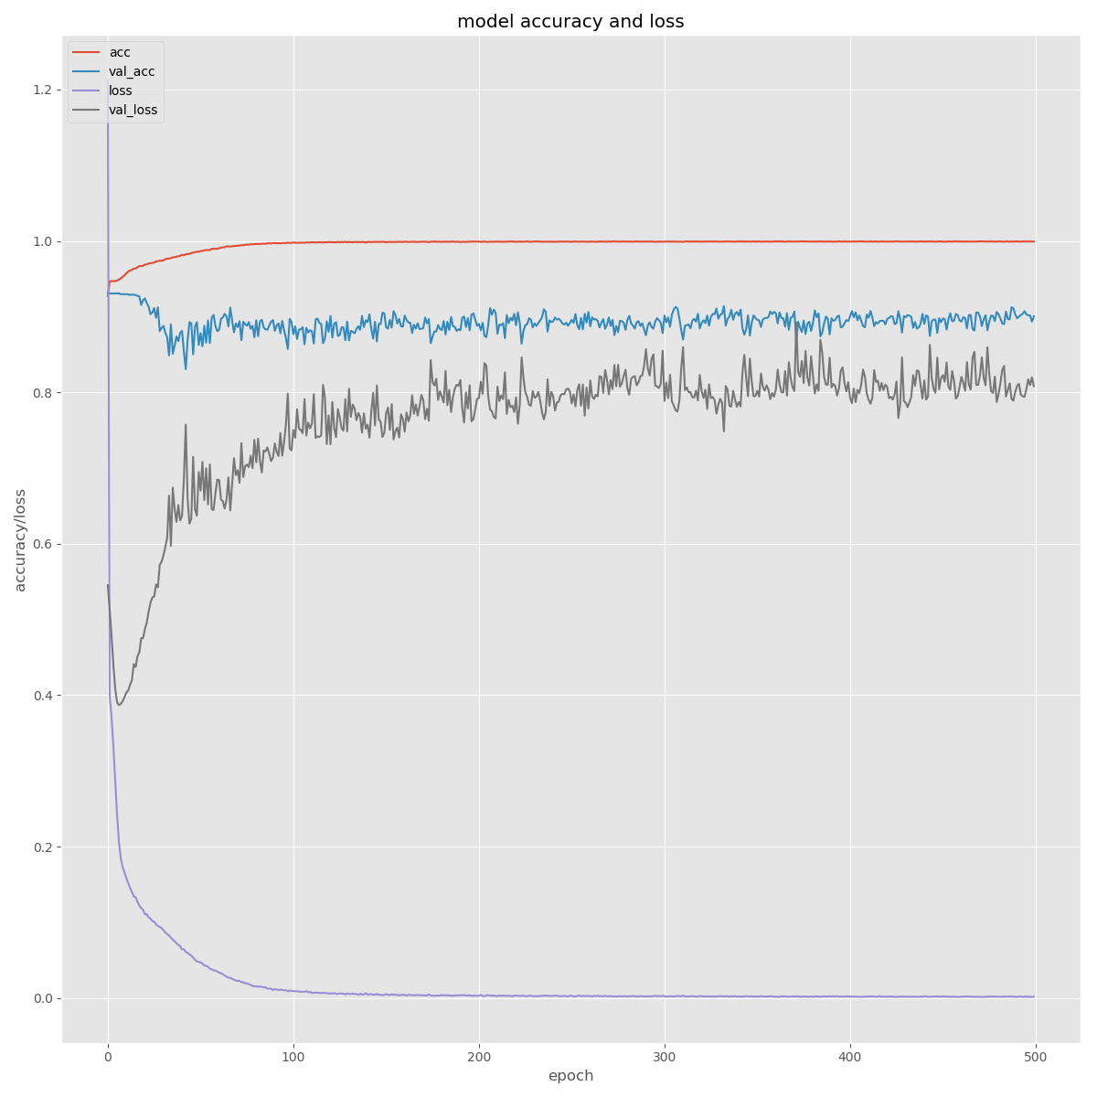
Figure 2: Graph for 500 epochs
LR: 0.001, ADAM, Tanh,

EPOCHS 30, LR : 0.00001, ADAM, Tanh
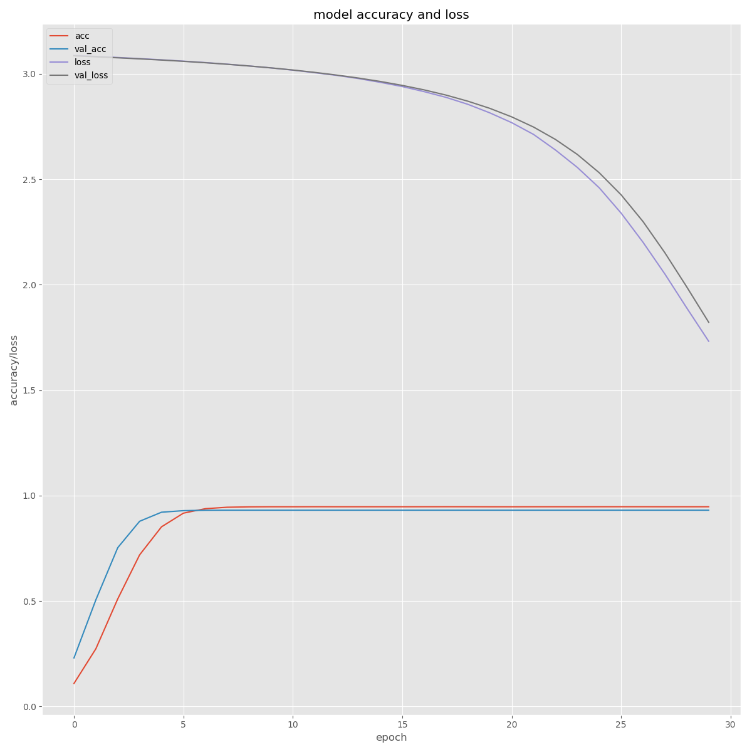
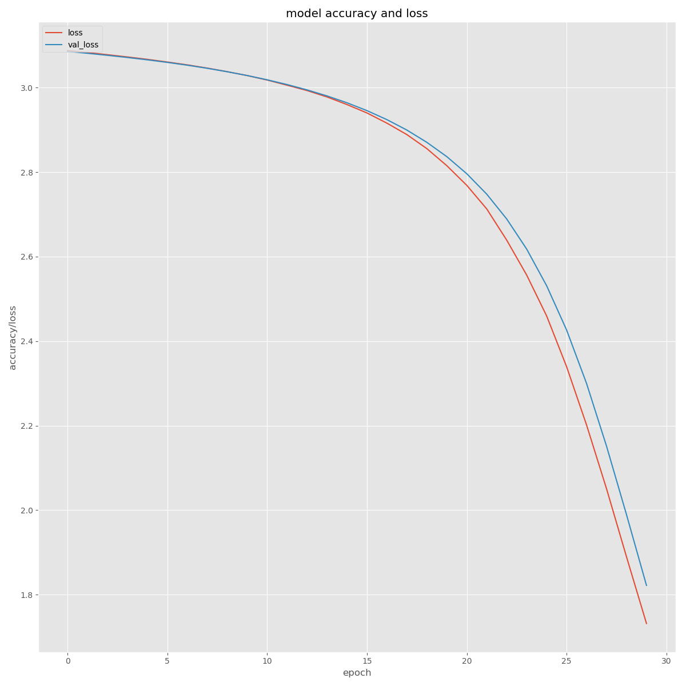

Previous Outputs
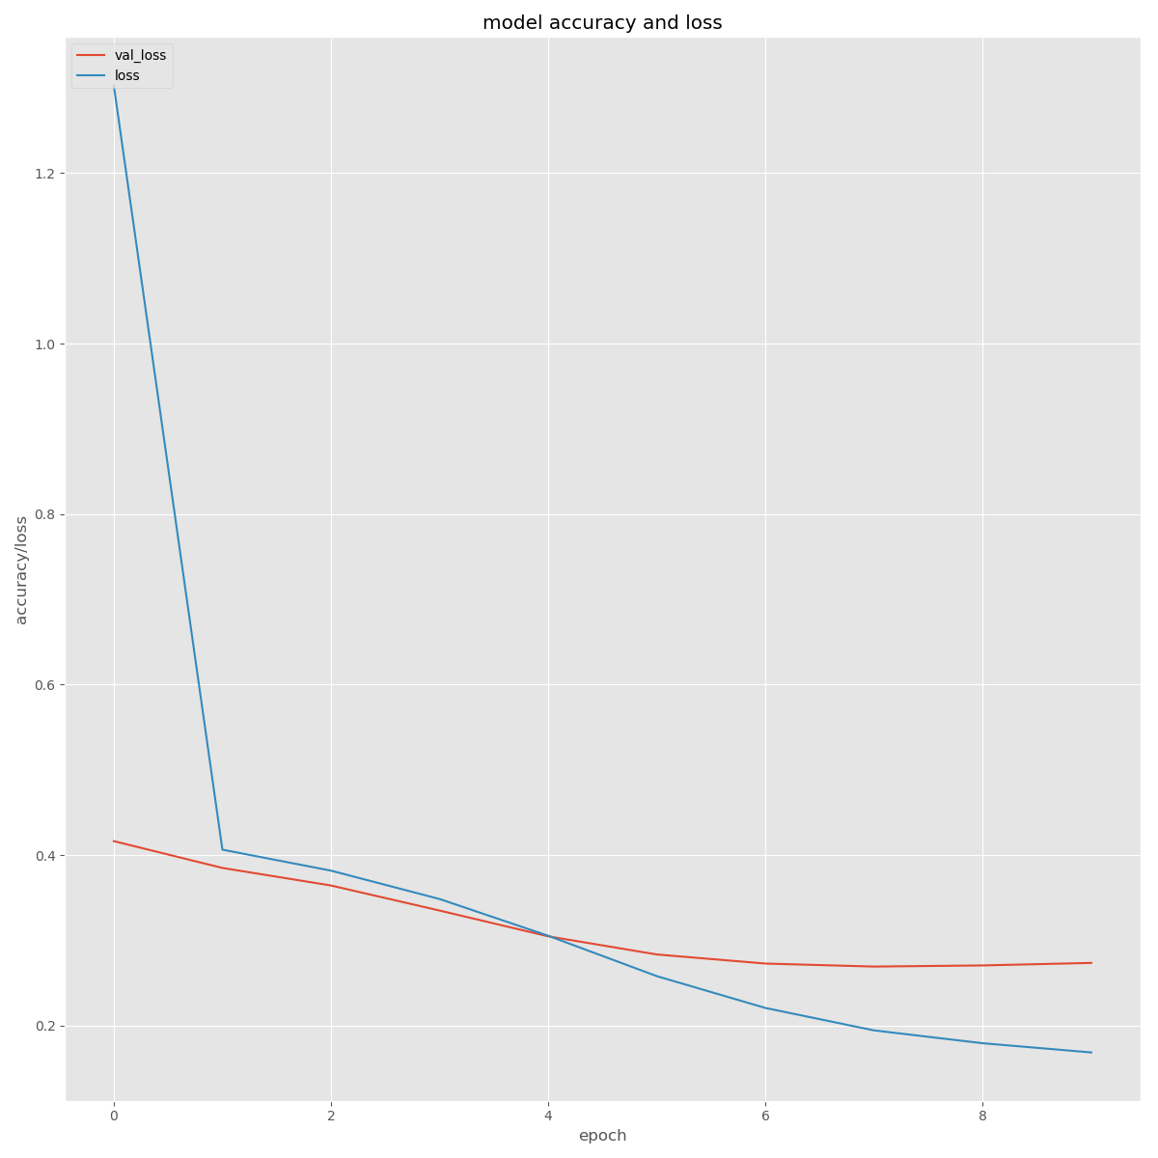

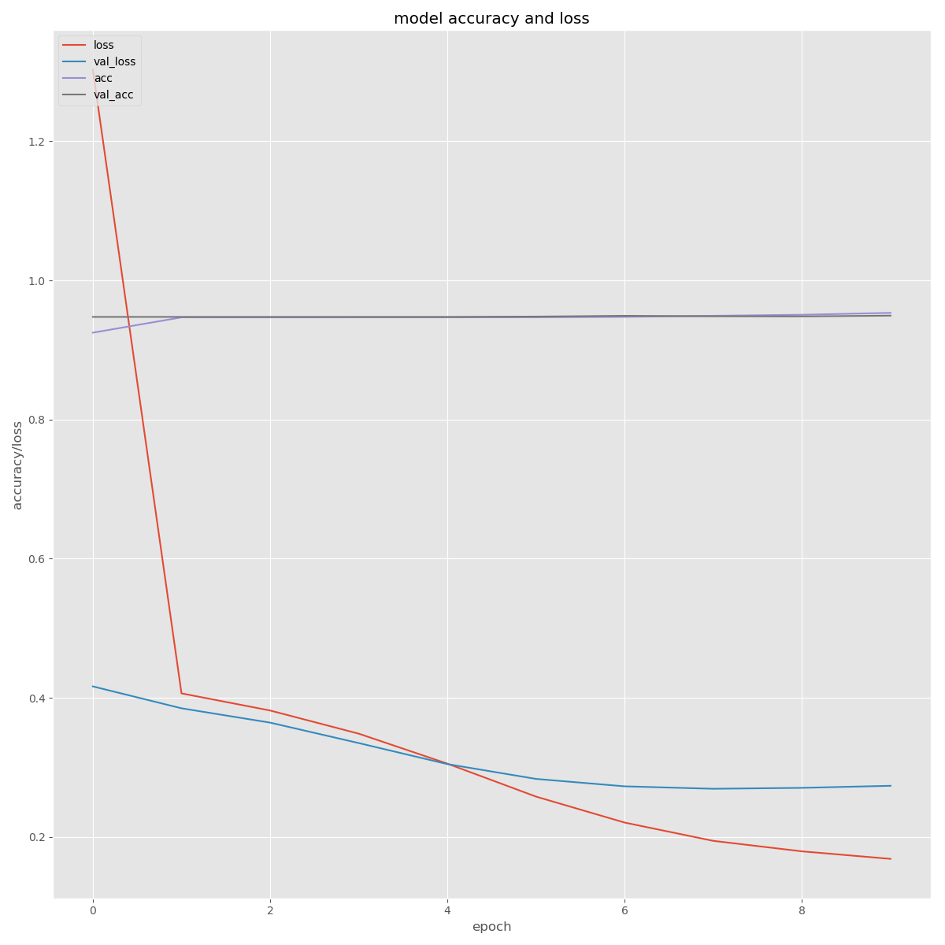

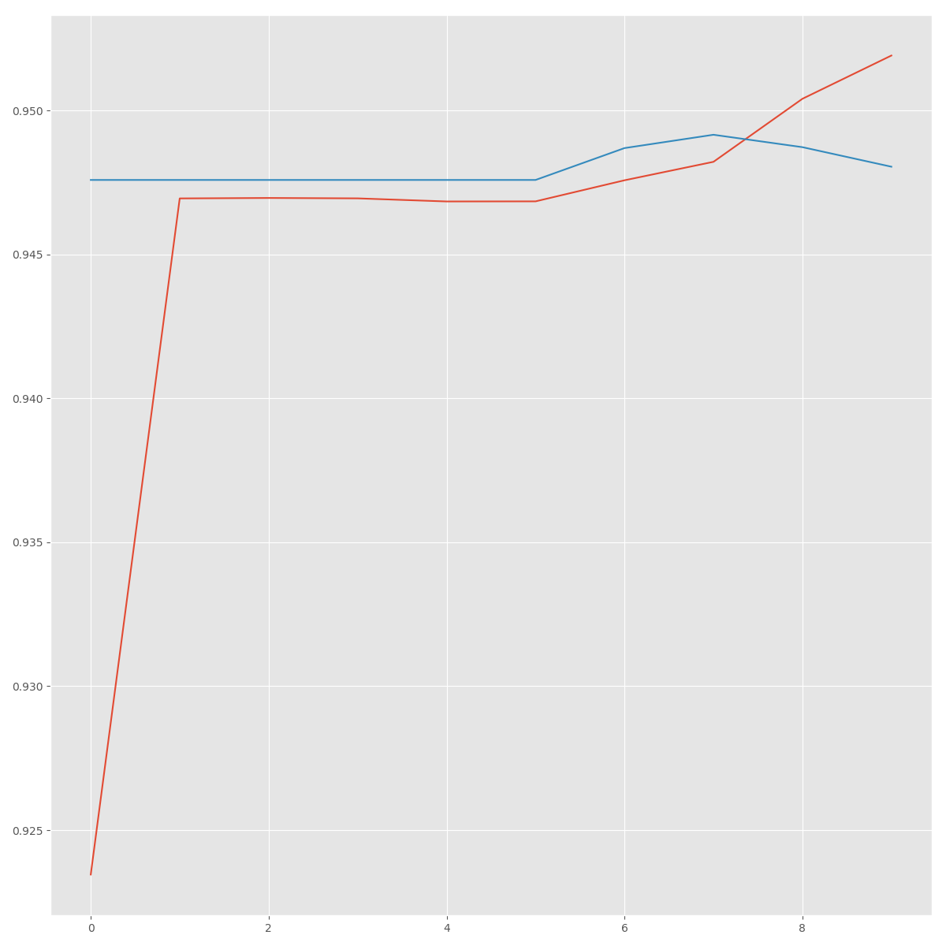

shapes: [(None, 75, 20), (None, 75, 10, 20)]

